An example of a data-driven answer is ranking “The Fortune 500 CEOs with the Best (and Worst) Headshots.” The answer was derived by using a unique AI photo analyzing software called Snappr Photo Analyzer. The analyzer rated the headshots based on eleven qualities. However, one issue I have with the study is the fact that it is ranking the headshots based on opinions. While it is possible that the AI ranked the pictures the way most people would, everyone has their own opinion. Although the ranking is opinion based, the idea of allowing CEOs of companies to see their rank and how to improve it is a good idea. It provides the CEOs with an easy way to make their company more sales, by having a self-portrait that seems nice and approachable.

Link: <https://priceonomics.com/the-fortune-500-ceos-with-the-best-and-worst/>

Another example of a data-driven answer is finding “The Companies Where Employees Most Often Get Payday Loans”. Payday loans are loans giving to people that need quick money for an emergency expense. The study found that majority of recipients taking out payday loans were employed full time. The study also found that the industry the recipients were working in were sales related. This could be because some sales related fields are commission based thus do not have a steady stream of income. I liked that the study included the employment status and industry of recipients taking the loans. I also like that the study had a wide range of companies and had a large list of fifty companies. The issue I have with the study is the industry and company with the most loan recipients does not add up. For instance, the industry with the most recipients were sales but the companies with the highest recipients were not sales related. Walmart, Target, USPS, and Amazon were all in the top ten but do not pay based on sales.

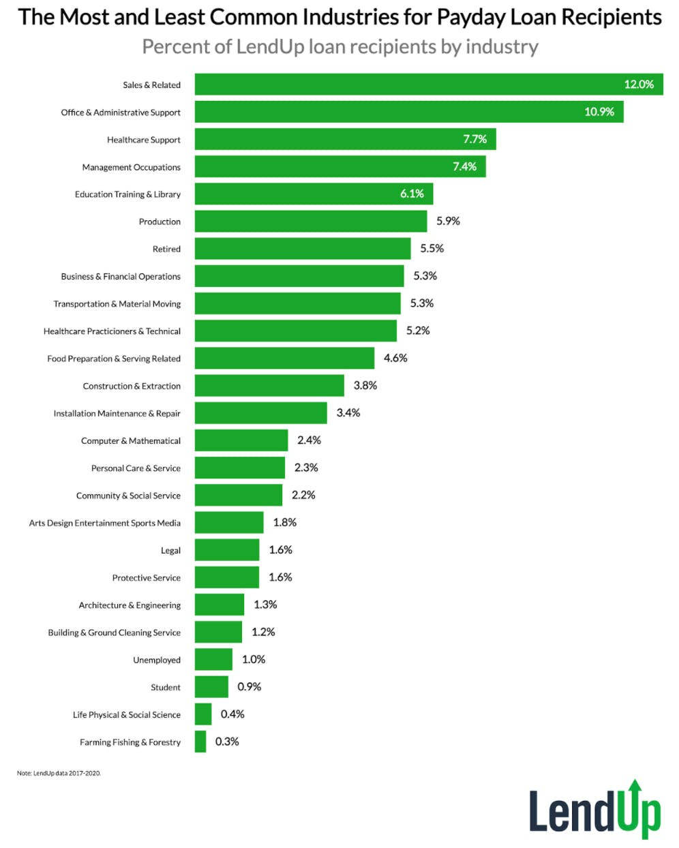

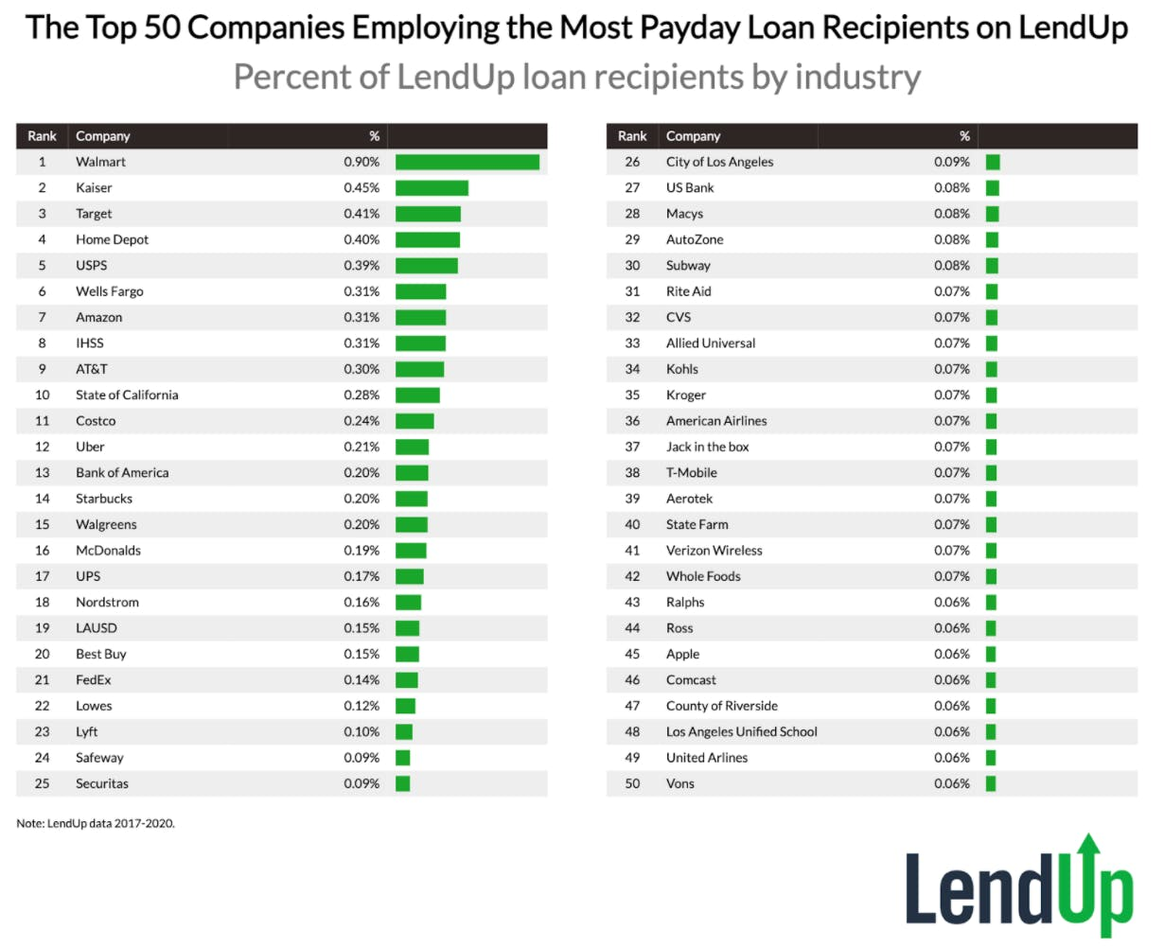Link: <https://priceonomics.com/the-companies-where-employees-most-often-get/>

A third example of a data-driven answer is “Which Industries Will Be Transformed By Blockchain (and the Ensuing Data Glut That Follows)”? The study looks at how likely blockchain will be used in certain industries. Blockchain is in essence a database that does not have a central location and is controlled by everyone. The article does a good job of highlighting the idea that blockchain could be used in industries besides cryptocurrency. The article also has a good visualization of the blockchain opportunities of several different industries. The visualization plots the industries based on the impact of blockchain and how easy implementation would be. The problem I have with the visualization is it plots a skewed average. Many of the industries are relatively close to one another with a few significant outliers. The outliers are dragging the average higher than it should be.

Link: <https://priceonomics.com/which-industries-will-be-transformed-by-blockchain/>

A fourth data-driven answer is about solar panels, “The Most Solar Places in America.” One of the studies in the article showed solar panel popularity by metro area. It showed solar panels were the most popular in San Diego, by far. In fact, the top 5 metro areas were all in California, indicating a huge popularity of solar panels in California. This could be because of the year-round sun in California. The article does a good job of proving this by including a visualization on the popularity of solar panels vs the number of days per year with sunlight. The article also does a good job of showing the number of solar panels across different metro areas. For example, the article shows the cities in San Francisco with the most solar panels, and the cities in Dallas with the most solar panels. It becomes easy to compare between the two different metro areas. However, one issue I have is the article included a visualization of the city where solar panels are the most popular. Roughly 90% of the 100 cities in the visual are in California. 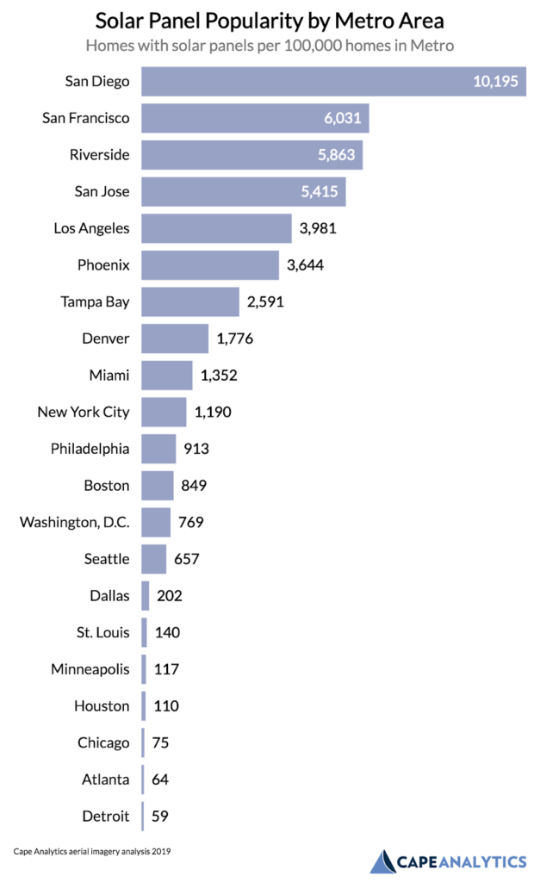The authors of the article should have changed the visualization to show only California cities.

Link: <https://priceonomics.com/the-most-solar-places-in-america/>